C:\Documents and Settings\MEL\Local Settings\Temporary Internet Files\Content.IE5\IW8K2N9F\MC900064950[1].wmf

Deaf and Hearing Impaired

How does the ear work?

Measuring Hearing Loss

Causes of Hearing Loss

Types of Hearing Loss

Hearing Loss and Learning

Accommodations/Services

Resources

By: Erin Crosby, Doua Her, Melissa Ponce, & Michelle Zozaya

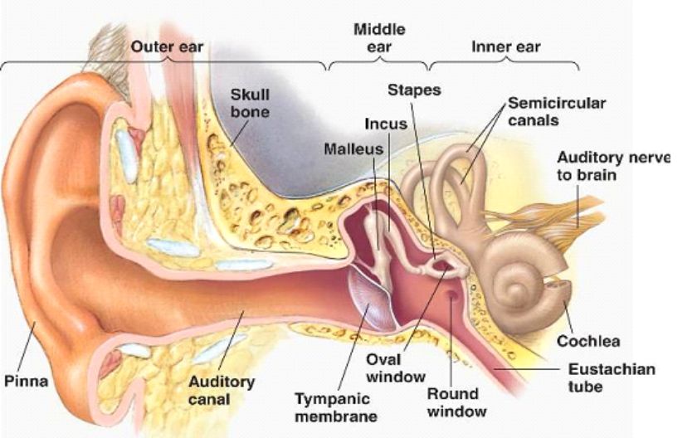

The structure of the ear can be divided into three parts:

* The outer or pinna, is responsible for collecting and funneling sound into the auditory canal and helping us place the original location of sound.
* The middle ear ends with the Tympanic membrane, or eardrum. Behind the eardrum is a small pocket of air containing three tiny bones, the Malleus, Incus and Stapes (or hammer, anvil and stirrup). These bones attach to and transmit sound vibration to a fluid filled structure called the Cochlea.
* The inner ear contains the Cochlea, where sound vibrations are transmitted into electrical impulses which are sent along the auditory nerve to the brain. The inner ear also contains Semicircular canals which are more responsible for equilibrium than hearing.

Hearing screens are typically administered to infants and school-aged children by using:

* Pure-tone air conduction hearing test
  + A typical test used in school.
  + Test is administered using earphones and requires the person taking the test to signal when they hear a sound.
  + Test determines the faintest tone a person can hear at different pitches and the results are recorded in an audiogram.
  + The audiogram graphs the decibel and hertz threshold of each ear.

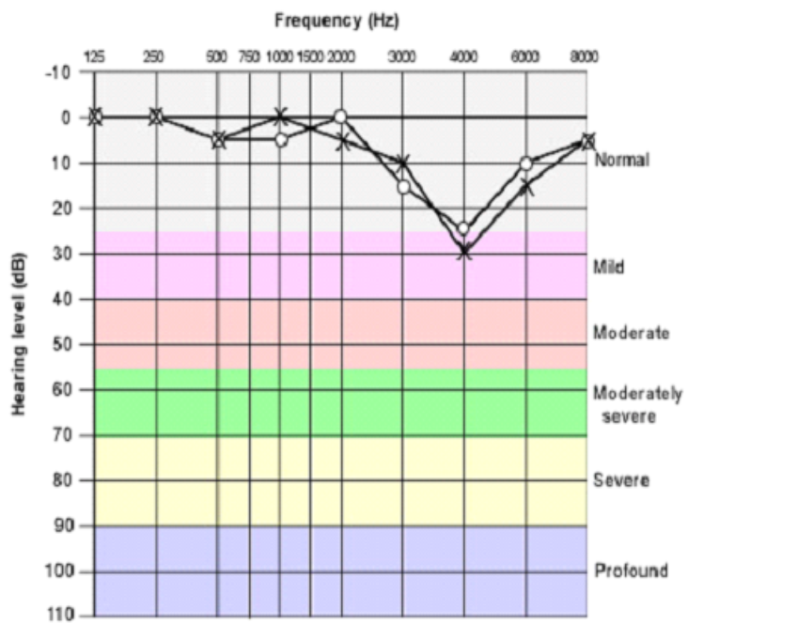

**Congenital Hearing Loss**

Hearing loss or deafness that is present at birth.

* It can include hereditary hearing loss or hearing loss due to other factors present either in utero (prenatal), or at the time of birth.
* Genetic Factors are thought to cause more than 50% of all incidences of congenital hearing loss in children.

**Acquired Hearing Loss**

Hearing loss which appears after birth and occurs at any point during one’s life. It may occur as a result of a disease, a condition, or an injury. Examples of these are:

* Ear infection (otitis media)
* Ototoxic drugs
* Meningitis
* Measles
* Encephalitis
* Chicken pox
* Influenza
* Mumps
* Head injury
* Noise exposure

**Noise**

The most common cause of acquired hearing loss is exposure to noise, which destroys the hair cells in the inner ear.

* Damage results after long-term exposure to loud noise, but even brief exposure to extremely loud noise can permanently harm hearing.
* About 30 million people in the United States are exposed to levels of noise that can cause hearing loss. Although people vary greatly in their sensitivity to loud noise, everyone loses some hearing if exposed to sufficiently loud noise long enough. Common sources of potentially damaging noise include highly amplified music, power tools, heavy machinery, explosions, gunfire, and many types of powered vehicles, such as snowmobiles. Many people are exposed to injurious levels of noise during the course of their jobs, and hearing loss is a significant occupational hazard for many people.

**Autoimmune Disorder**

Autoimmune disorders sometimes cause hearing loss. Examples of these are:

* Rheumatoid arthritis
* Systemic lupus erythematosus
* Polyarteritis nodosa
* A fluctuating hearing loss, which may be progressive, occurs in both ears. The cause is an attack by the immune system on the cells of the cochlea.

**Drugs**

Intravenous antibiotics in the **aminoglycoside** family are the drugs most commonly implicated, particularly when given in high doses.

* Some people have a rare hereditary disorder that makes them extremely susceptible to hearing loss caused by aminoglycosides.
* Other drugs include: vancomycin, quinine, and the cancer chemotherapy drugs cisplatin and nitrogen mustard.
* Hearing loss can be caused by aspirin (salicylate), but hearing can come back when the drug is discontinued .

**Sudden Deafness**

Deafness that occurs within minutes, or over a few hours. This is commonly caused by:

* Wax accumulation
* Head trauma
* Sudden change in pressure (as occurs in airplanes)
* Internal pressure changes caused by severe straining (as may occur with weight lifting)
* Infections
* Drugs
* Disorder of the blood vessel to the ear

**Tumors**

Hearing loss that is more severe in one ear may be caused by a non-cancerous (benign) tumor. Such tumors include:

* A vestibular schwannoma (more commonly termed as acoustic neuroma)
* Meningioma

**Mechanical**

Hearing loss may be caused by a mechanical problem in the external ear canal or middle ear that blocks the conduction of sound (conductive hearing loss).

* Blockage of the external ear canal can be due to something as mundane as an accumulation of wax, or something as uncommon as a tumor. The most common cause of conductive hearing loss in the middle ear, especially in children, is an accumulation of fluid. Fluid can accumulate as a result of ear infections or conditions, such as allergies or tumors that block the eustachian tube, which drains the middle ear. Other mechanical causes of hearing loss include the presence of a foreign object that can get stuck in the ear or cause damage beyond the ear drum. Examples include:
  + Q-tips that are pushed too far into the ear canal
  + Car wrecks
  + Fights
  + Sporting injuries
  + Water (diving)
  + Air pressure

**Aging**

Age-related hearing loss is called presbycusis.

* As some people age, structures of the ear become less elastic and undergo other changes that make them less able to respond to sound waves, contributing to hearing loss.
* The damage lies in the inner ear, the hearing nerve, or in both.
* The gradual loss of hair cells and nerve endings within the cochlea (the region that hears very high frequencies) results in sensoneurial hearing loss.
* Age-related hearing loss begins early, starting some time after age 20; however, it progresses very slowly, and most people do not notice any changes until well after age 50.
* Age-related hearing loss first affects the highest pitches (frequencies) and only later affects lower pitches.
* Loss of the ability to hear high-pitched sounds often makes it more difficult to understand speech.
* Although the loudness of speech seems normal to the person, certain consonant sounds—such as the sound of letters C, D, K, P, S, and T—become hard to distinguish, so that many people with hearing loss think the speaker is mumbling.
* Words can be misinterpreted. For example, a person may hear “bone” when the speaker said “stone.” Some people complain more that others are not speaking clearly rather than that they cannot hear well. Women and children, whose voices tend to be higher in pitch than those of men, are particularly difficult to understand.
* Many people also notice a change in the vibrancy of certain musical sounds, such as those of violins and flutes.

**Conductive Hearing Loss**

* Reduction in hearing sounds
* Sound is not “conducted” efficiently from outer ear to eardrum
* Can be mild to moderate in degree
* May be unilateral or bilateral
* Hearing aids and surgery can help

**Central Hearing Loss**

* Problem lies in the central nervous system (CNS)
* Interpreting speech becomes a complex tasks

**Sensorineural Hearing Loss**

* Most common type of permanent hearing loss
* Damage to the inner ear (cochlea) or the nerve pathways from the inner ear to the brain
* Cannot be corrected by medical or surgical procedures

**Mixed Hearing Loss**

* A combination of both conductive hearing loss and SNHL
* There may be damage in the outer or middle ear and in the inner ear (cochlea) or to the nerve pathways from the inner ear to the brain

Under IDEA, the U.S. Department of Education (2007) reports that 76,522 students ages 3 to 21 receive special education services under the category of “hearing impairment”. 14,787 children receive audiological services in early intervention programs. Individuals who are deaf and hard of hearing will have the following mandated services:

**Identification Services**

* Early identification of deaf and hard of hearing individuals can lead to higher success rates later in life.
* Identified infants and toddlers (birth-36 months) are serviced under Part C of IDEA-California Early Start Services.
* Identified children ages 3 through 21 are serviced under Part B of IDEA.

**Who is Responsible for Services?**

* School Districts
* County Office of Educations
* Special Education Local Plan Areas

**Assessment Services**

* Audiological
* Communication/Language Skills
* Manual Communications (i.e. ASL)
* Spoken Language
* Written Language
* Telecommunication Skills (i.e. TTY)
* Preacademic Skills
* Academic Skills
* Motor Skills
* Psychological

**Support Services**

* Program Specialist
* Site Administrator
* Resource Specialist
* Instructional Aide
* General Education/Special Education
* Speech, language, and hearing specialist
* Audiologist
* Educational Interpreter
* Real-time captioner
* Note-taker
* Adapted physical Education teacher
* Occupational/ physical therapist
* Career/vocational specialist
* Psychologist
* School nurse

**Individualized Education Plan (IEP) Services**

The IEP team supports the needs of the student by providing equal access to education and meeting expected goals and objectives. The following support may be provided:

* Specialized Services (i.e., sign language, interpreting, oral or Cued Speech transiliteration, note-taking, real-time captioning)
* Materials and equipment (i.e., assistive listening device, close-captioned television, telecommunication device for the deaf, amplified telephone, captioned videos, specialized curriculum)
* Accommodations (i.e., acoustically appropriate classroom, preferential seating, lighting)

**Specific Communication Needs**

Consider the communication needs of the student.

* Language of communication
* Opportunities:
  + Direct communications with peers
  + Direct instructions

**Specific Service Needs**

* Speech and language pathologist
* American Sign Language (ASL) specialist
* Counselors
* Career and Vocational

**Social and Emotional Needs**

Students who are deaf and hard of hearing may experience difficulty initiating and maintaining friendships, isolation**,** and low self-esteem**.** Counseling services play an important role in teaching students specific skill sets necessary for social and emotional success in schools.

**In-Class Needs**

* Amplification system
* Services of ASL interpreters
* Captioned films/services
* Assistance of note takers
* Instructions in alternate modes of communication

**Additional Support**

Deaf and hard of hearing students may be referred to specialized outside agencies if there are concerns with the current program placement, a lack of progress being made, behavioral problems, specific educational problems, or a need for further educational planning. The agencies offered are listed below:

*Northern California Assessment Center for the Deaf and Hard of Hearing (California School for the Deaf, Fremont)*

*Southern California Assessment Center for the Deaf and Hard of Hearing (California School for the Deaf, Riverside)*

**Statistics**

Research by Blanchfield et al (2001) found the following about individuals who are deaf and hard of hearing:

* 44.4% do not graduate from high school
* Only 5.1% graduate from college
* Only 4.8% have post-college education
* *American Sign Language (ASL)*: ASL is commonly used in the North American Deaf Community and is a rich and complex visual-gestural language, with grammatical structure unlike English.
* *Auditory-verbal:* Amplifications help teach children to listen, process spoken language, and speak without the use of signs, cues, speech reading, or other visual cues.
* *Bilingual-bicultural (Bi-Bi)*: An educational method and philosophy emphasizing deaf culture. ASL is the primary mode of communication, while English is taught as a second language.
* *Cued Speech*: A visual communication system which uses eight hand shapes in four locations (“cues”) in combination with the natural mouth movements of speech to make all the sounds of spoken language look different.
* *Manually coded English (MCE):* MCE includes a number of different signing systems in which finger spelling and American Sign Language signs are used in English word order. Signs are created for words for which there are no ASL equivalents, and for English suffixes and prefixes, in order to represent the vocabulary and grammatical structure of spoken English as explicitly as possible.
* *Oral-aural:* Encourages the individual to use their residual hearing (with the aid of amplification) to develop spoken language skills. While signs and finger spelling are not used in oral/aural programs, children are encouraged to use speechreading (reading lips and facial expressions) in learning to understand and use connected speech.
* *Simultaneous communication* (*Sim Com)*: Spoken language plus MCE
* *Tactile communication*: Accessing language through touch (i.e., Braille)
* *Total communication*: A philosophy that encourages equally the development and use of speech, speechreading, sign language and finger spelling, and written language*.* MCE is often used so that speech and sign may be used simultaneously*.* ASL or Cued Speech or both are also used in some total communication programs.
* American Society for Deaf Children

<http://www.deafchildren.org/>

* Raising and Educating a Deaf Child

<http://www.rit.edu/ntid/educatingdeafchildren/>

* American Speech-Language-Hearing Association

<http://www.asha.org>

* Parents of Deaf and Hard of Hearing List Serv

<https://listserv.kent.edu/cgi-bin/wa.exe?A0=PARENTDEAF-HH>

* National Center for Hearing Assessment and Management-Utah State University

<http://infanthearing.org/>

* National Dissemination Center for Children with Disabilities

<http://nichcy.org/>

* <http://www.cdc.gov/ncbddd/hearingloss/facts.html>
* <http://www.asha.org/public/hearing/disorders/children.htm>

* <http://www.infanthearing.org/states_home/index.html>
* <http://nichcy.org/disability/specific/hearingloss/>
* <http://deafness.about.com/od/articlesandnewsletters/a/causes.htm>
* <http://library.thinkquest.org/26209/causes.html>
* <http://www.merckmanuals.com/home/ear_nose_and_throat_disorders/hearing_loss_and_deafness/hearing_loss_and_deafness.html?qt=hearing%20loss&alt=sh>
* <http://www.iu.edu/~emusic/acoustics/ear.htm>
* <http://library.thinkquest.org/26209/causes.html>
* <http://www.csus.edu/indiv/b/brocks/Courses/EDS%20247/4a.%20Hearing/Week%204a.%20Hearing%20Impaired.pdf>

* <http://nichcy.org/wp-content/uploads/docs/fs3.pdf>